Screenshots and Comments

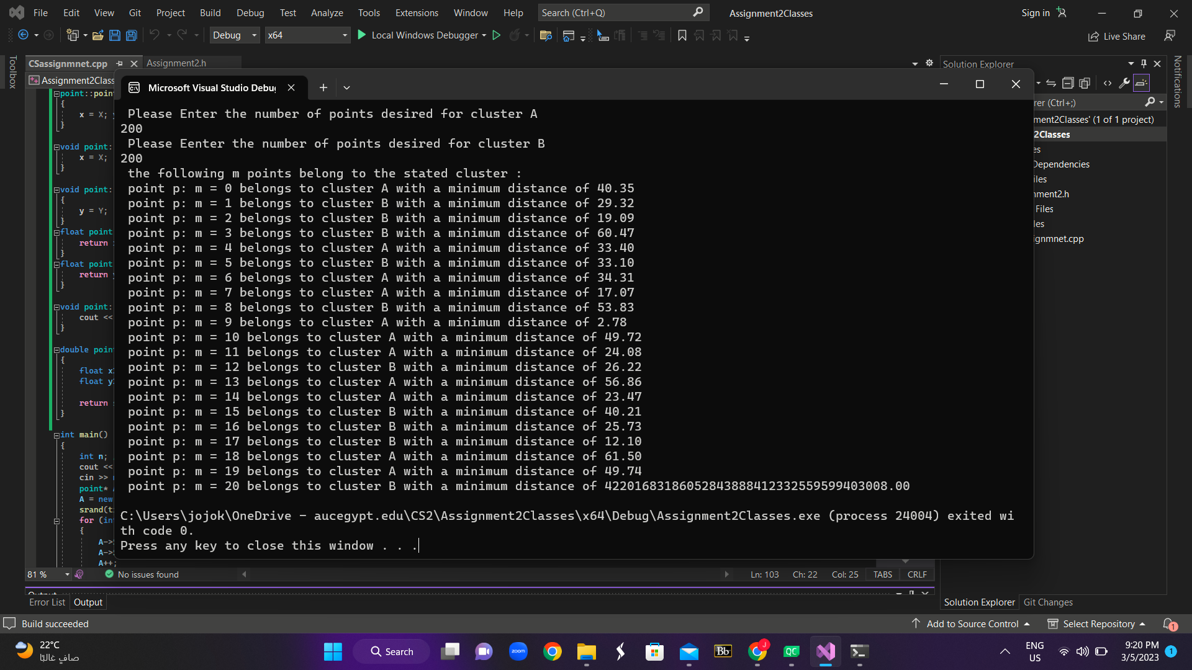

Comments: the last point has a minimum distance of a complex number even though I used set precision and fixed.